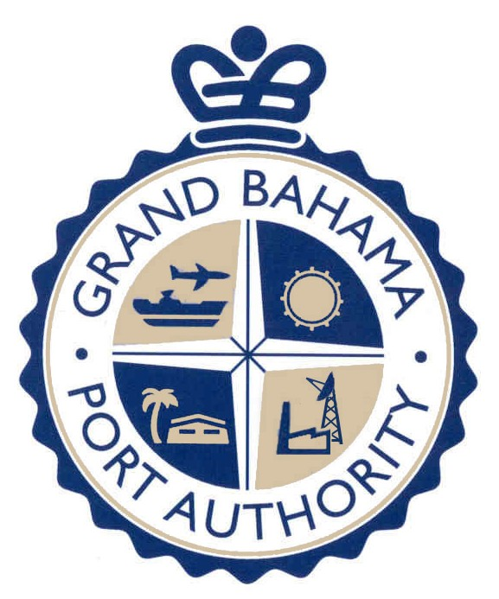
PRESS RELEASE
For Immediate Release

Wednesday, 27th September 2006 – The Chairman and Executives of The Grand Bahama Port Authority are pleased to reassure the public that investor confidence in Grand Bahama has not been affected by the recent negative statements which have been made by certain individuals in the press.

Various projects which have been attracted to Freeport by the new management team at the Port Authority are in an advance stage of negotiation and which shall materially improve the economy of Grand Bahama.

We also wish to confirm that we have had no negative reaction to investment in Freeport thus far, as a result of those negative statements and are encouraged in respect of the sustained interest of investors in the economy of Freeport.

“As Chairman of the Port Authority, I would like the public to know that I enjoy the full support and cooperation of the Management Team at the Port Authority, and we are working aggressively to improve the Freeport economy” stated Hannes Babak.

###

