TOUR OPERATOR AND MEDIA EXIT SURVEY
2008

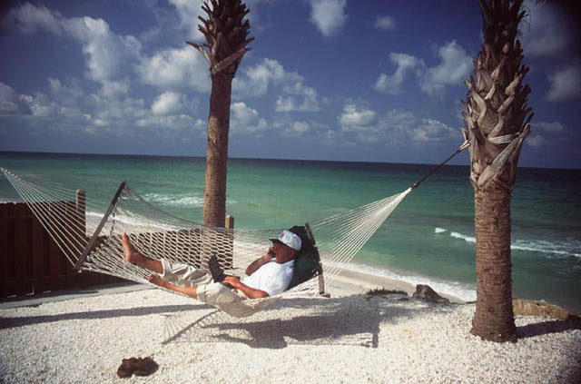

THE ISLANDS OF THE BAHAMAS
RESEARCH & STATISTICS DEPARTMENT
BAHAMAS MINISTRY OF TOURISM

TABLE OF CONTENTS

- EXECUTIVE SUMMARY 3

- INTRODUCTION 7

- METHODOLOGY 8

4. REASONS FOR VISIT TO THE BAHAMAS 10

5. WHAT INFLUENCED VISITORS TO VISIT THE BAHAMAS 12

6. WHAT ACTIVITIES DID VISITORS INTEND TO DO IN BAH. 14

7. REPEAT VISITORS VS. FIRST TIME VISITORS 16

8. VISITOR MEDIA CHOICES 19
i) Electronic Media Used For Planning Vacations 19
ii) Use of TV & Favorite Television Networks 21
iii) Time Visitors Most Likely to Watch Television 29
iv) Print Media Used When Planning Your Vacation 32
v) Use of Magazines & Magazines Visitors Read 34
vi) Use of Newspapers & Newspapers Visitors Read 44

9. NO. OF PEOPLE WITH E-MAILS & WHO SURF INTERNET 54

10. FAVOURITE INTERNET SEARCH ENGINES/PROVIDERS 56
11. LIKELIHOOD TO RETURN & RECOMMEND THE BAH. 57
i) Visitors who were not likely to return or recommend 61

12. TOURIST COMMENTS 67

13. RESERVATION BOOKINGS 74
i) How Did You Book Your Reservations 74
ii) Amount of Time Between Reservation & Visitor Arrival 75
iii) Use of Tour Operator/Travel Agents/Online Services 76

14. DEMOGRAPHICS BY ISLAND 86
15. CONCLUSION 105
16. APPENDIX: Questionnaire 110
EXECUTIVE SUMMARY
Reason for Visit
- The main reason visitors to the Islands of the Bahamas came to the Islands of the Bahamas was to vacation.
- Visitors to The Islands of The Bahamas said that the following influenced their decision to visit: the beaches, the climate, rest and relaxation, the hotel facilities, the friendly people, ease of getting to the island, the fact that they had never been to the Bahamas before, and the perceived safety of the islands.
- The Islands of the Bahamas did differ somewhat on the influences that made the visitor choose each of the islands for their vacation experiences.
- Visitors to Nassau/Paradise Island were also influenced to visit the destination because of the casinos, and the good package deals offered to the destination.
- Visitors to Grand Bahama were also influenced to visit the destination by the perception that they would receive the best value for money.
- Visitors to the Out Islands were also influenced to visit these islands because of the sporting attractions available, the perception that the islands were exotic, a friend had recommended the destination or they had friends in the Bahamas.

Electronic Media Used
- The electronic media most frequently used when planning a vacation was the Internet, followed by Network Television, Specialty Cable Channels and Specialty New Channels.
- The favorite television networks & television stations of visitors to the Islands of the Bahamas in general were: CNN (Specialty News Station), NBC (Network Station), ESPN (Specialty Cable Channel), ABC (Network Station), FOX (Network Station), CBS (Network Station), and HBO (Specialty Cable Channel).
- Visitors to the Islands of the Bahamas watched television primarily between 6:00 p.m. and 10:59 p.m. at night. The most popular time of the day for watching television was between 8:00 p.m. to 8:59 p.m.

Print Media Used

The most popular print media used by visitors to the Islands of the Bahamas when planning their vacations included magazines and newspapers. Magazines were the more popular of the two.

Some of the most popular magazines for visitors to the Bahamas were: People, Time Magazine, Cosmopolitan/Cosmo, US/US Weekly, Newsweek, Sports Illustrated, Glamour, O (Oprah), Vogue/Vogue Living, National Geographic Explorer, Men’s Health, In Style, Vanity Fair, The Economist, Good Housekeeping, Better Homes and Gardens, the New Yorker, GQ, Fitness, Essence, Readers Digest, Ebony, Conde Nast Travel, Elle Décor, Travel and Leisure, Southern Living, OK!Magazine, Self, Real Simple, Maximum/Maxim, Golf, Travel, Star, Woman’s Day, and Jet.

Some of the top newspapers read by visitors to the Bahamas were: USA Today, The New York Times, Wall Street Journal, Washington Post, New York Post, Newsday, Globe and Mail, Boston Globe, Miami Herald, the Daily News, Sun Sentinel, Atlanta Journal-Constitution, Los Angeles Times (L.A. Times), Toronto Star, and the Chicago Tribune.

Internet Usage

84% of the stopover visitors to the Islands of the Bahamas said that they had e-mail addresses.

90% of them said that they “surfed” the Internet.

Some of the top Internet search engines/content providers for visitors to the Bahamas were: Google, Yahoo, AOL, and MSN. In 2008, there were more visitors to the Bahamas using Google than in 2007, i.e. their market share increased by 7 percentage points.

Tour Operators & Travel Agents

30% of the stopover visitors to the Bahamas used a tour operator or travel agent to book their reservations.

Some stopover visitors used a combination of methods to make their reservations, i.e., tour operator/travel agent, direct bookings and/or online on the Internet. The stopover visitors who did not use a tour operator or travel agent to book their reservations either booked their reservations directly or via the Internet.

Some of the visitors to the Islands of the Bahamas who booked their reservations online used: expedia.com, atlantis.com, orbitz.com, travelocity.com, aa.com, jetblue.com, Usairwaysvacations.com, continental.com, sandals.com, spiritair.com, carlsonwagonlit.com, delta.com/deltavacations.com, cheaptickets.com, bahamasair.com, Bahamas.com, aircanada.com, ba.com, firstchoice.co.uk, gradcity.com, nwa.com, airfrance.com, americanexpress.com, aol.com, Bahamasvacations.com, bookit.com, clubmed.com/clubmed.ca, colpittsworldtravel.com, comfortsuites.com, cosco.com, fourseasons.com, funjet.com, grandbahamavacations.com hotels.com, hotwire.com, intervalinternational.com, kayak.com, macystravel.com, Paradiseislandvacations.com, priceline.com, rci.com, Riu.com, Sheraton.com, skyauction.com, smallhope.com, spg.com, spiritair.com, starwood.com/westin.com, superclubs.com, travelzoo.com, united.com, Usairwaystravel.com, vacationstogo.com, virgin-atlantic.com, virtuallythere.com, Westjet.com, wyndham.com, and yahoo.com.

Some of the popular tour operators/travel agents for the Bahamas Overall were: Liberty Travel, American Express Travel, Discovery Cruise Line, AAA Travel/Triple AAA, Club Med, RCI Travel, Security Travel, GOGO Tours, Apple Vacations, Student City, Thomas Cook Travel, Uniglobe Travel, Travel Impressions, Maritz Travel, and Bel Air Travel.

Likelihood of Return & Recommend

87% of the stopover visitors said that they were likely to return to the Bahamas in 1-5 years. (i.e., 59.5% of them were very likely and 27.1% of them were somewhat likely to return to The Bahamas).

93% of the stopover visitors said that they were likely to recommend the Bahamas to friends and relatives. (i.e., 69.6% of them indicated that they were very likely and 22.9% were somewhat likely to recommend The Bahamas to friends and relatives).

- Visitors to the Bahamas who were not likely to return or recommend the Bahamas to friends and relatives gave these reasons: high prices (too expensive), they wanted to visit other places, hotel dissatisfaction (e.g., poor accommodations, rude staff, poor hotel service), poor service, poor attitudes of the people, food (too expensive or poor quality), litter/cleanliness (country was too dirty), and crime.

How and When Did Visitors book their Reservations?

Visitors to the Bahamas seemed to prefer short lead times when booking their reservations. They appeared to prefer to book their reservations the same month of travel or 1-3 months in advance of travel.

Demographics

Visitors to the Bahamas were primarily white, between the ages of 25-54, college educated, with annual household incomes over $75,000.

81% of the stopover visitors were from the United States and 8% were from Canada.

59% of the visitors to the Islands of the Bahamas were repeat visitors.

The average length of stay of stopovers to the Bahamas was 6.6nts.

INTRODUCTION

The Ministry of Tourism has undertaken a survey of tourists leaving the Islands of The Bahamas since the early 1970’s. The information contained in this Exit Survey report was especially designed to capture information on important visitor trip characteristics such as the reason for visit, what influenced a visitor’s decision to visit, what they wanted to do when they got to the destination and reservation booking patterns. It was also designed to capture various media used by visitors to the Islands of The Bahamas when planning vacations. This report also contains information from the Immigration cards.

RESEARCH OBJECTIVES

- Obtain information on trip characteristics (reasons for visit, etc.)
- Obtain information on what influenced visitors to visit The Bahamas
- Obtain information on the activities visitors intended to do on this visit
- Obtain information on reservation bookings
- Obtain information on Online Services/Tour Operators &/or Travel Agents
- Obtain information on electronic media used for planning a vacation
- Obtain information on favorite television networks
- Obtain information on the time visitors to the Bahamas were most likely to watch television
- Obtain information on print media choices (e.g., newspapers & magazines read)
- Obtain information on the number of people who had e-mail addresses
- Obtain information on favorite internet search engines & or content providers
- Measure intention to return and recommend
- Obtain demographic information on the stopover visitors (age, sex, education, household size, income).

METHODOLOGY

This Exit Study sample consists of stopover visitors to The Islands of The Bahamas. Stopover Visitors consists of non-residents travelling to the islands to stay in land-based accommodations and/or pleasure crafts/yachts other than cruise ships for 24 hours or more. In 2008, The Islands of The Bahamas received an estimated 1,463,006 stopover visitors compared to 1,527,727 in 2007, a decline of 4.2%. The majority of stopover visitors 1,177,271 (80.5%) were from the U.S.A. The other stopovers to The Islands of The Bahamas were from Canada, 114,960 (7.9%), Europe, 93,803 (6.4%), and Other Countries 76,972 (5.3%).

The method used in the selection of the sample for this Exit Study can be described as a two-staged Systematic Probability Sampling. With this method every kth element (mainly every 5th person) in the sampling frame is selected. Interviews of exiting stopover visitors were conducted at major airports throughout the country. The islands surveyed in this Exit Study include Nassau/Paradise Island, Grand Bahama, Abaco, Andros, Eleuthera, Exuma, Bimini and San Salvador. Interviews during the sampling process were conducted in the mornings, afternoons and evenings.

A total of 5,279 questionnaires were collected from stopover visitors and analyzed. The results were weighted to reflect the place of stay during the visit and the country of residence of the visitor. The published results, therefore, are weighted data and more accurately reflect the real situation.

As with any survey dependent upon random sampling, the percentages and averages in this report are subject to sampling error. The sample is used to estimate the population and differences exist between the result of the sample and the true underlying population value that is unknown. Sampling tolerances (error) for the percentages in this report are shown on the next page.

For example, if 50% of the stopover visitors to Nassau/Paradise Island gave a particular response, 95 times out of 100 times, the answer would be no higher than 52.5% and no lower than 47.5% (a margin of plus or minus 2.5%).
TOUR OPERATOR AND MEDIA EXIT SURVEY
MAIN FINDINGS
2008

- 70% of all stopover visitors to The Bahamas were on vacation.
- 7% of them were on business.
- 5% of the stopovers to The Bahamas were on honeymoon. 6% of the stopovers to Nassau were on honeymoon compared to 11% in 2001.
- 4% of them were visiting friends/relatives.
- 3% of them came for a Convention and Conference.
- 2% of them came to the Bahamas to attend a wedding and 1% came to get married.
- 3% of the stopover visitors came on a Casino excursion or for some other reason.

WHAT INFLUENCED VISITORS TO DECIDE TO VISIT THE BAHAMAS?

TOP INFLUENCES FOR DECIDING TO VISIT THE BAHAMAS
ISLANDS OF THE BAHAMAS
2008
 | Bahamas | Nassau/P.I. | Grand Bahama | Out Islands
Beaches | 60% | 60% | 60% | 64%
Climate | 51% | 51% | 50% | 53%
Rest and Relaxation | 43% | 43% | 43% | 42%
Hotel Facilities | 28% | 34% | 15% | 19%
Friendly People | 26% | 24% | 24% | 36%
Easy to Get to | 21% | 21% | 21% | 20%
Never Been Here Before | 21% | 21% | 23% | 17%
Safety of Islands | 15% | 14% | 14% | 20%
Exotic Islands | 13% | 12% | 11% | 17%
Casinos | 12% | 16% | 8% | 2%
Good Package Deals | 11% | 13% | 13% | 5%
Friend recommended Bah. | 11% | 11% | 10% | 13%
Other | 11% | 9% | 13% | 12%
Sports | 11% | 6% | 12% | 25%
Heard a lot about Bahamas | 9% | 11% | 8% | 7%
Best Value for Money | 8% | 7% | 14% | 7%
Had Friends in Bah. | 8% | 7% | 8% | 12%
Shopping | 6% | 7% | 6% | 2%
Nightlife | 4% | 5% | 4% | 3%
Travel Agent/Tour Operator | 4% | 5% | 3% | 3%
Bahamas Website | 4% | 4% | 3% | 3%
Saw Ad on TV | 2% | 2% | 1% | 0%
Saw Ad in Magazine | 1% | 1% | 1% | 1%
No Response | 5% | 5% | 6% | 4%

Visitors to the Islands of the Bahamas indicated that their decision to visit was influenced by:

- The beaches
- Climate
- The need for rest & relaxation
- Hotel facilities
- Friendly people
- The ease of getting to the Bahamas
- The fact that they had never been here before
- The safety of the islands (they perceived the islands to be safe)
- The perception that The Bahamas was exotic
- The Casinos
- Good package deals offered to the destination
- Friends had recommended the destination
- They had friends in the Bahamas
- They had heard a lot about the Bahamas
- Sporting attractions available in the destination (e.g. snorkeling, diving, sailing, deep sea fishing, golfing, and bonefishing)
  - For the Out Islands, sporting attractions really stood out as a major influence for visiting. In addition to the sport of snorkeling which was important to visitors to all of the Out Islands in the Bahamas there were some sporting activities that stood out by island.
  - For the island chain known as The Abacos (Abaco), sailing was a major sporting activity that visitors wanted to enjoy.
  - For the island of Andros, bonefishing and diving really stood out as activities that visitors to the island intended to enjoy while there.
  - For Bimini, deep sea fishing and diving really stood out.
  - For the Exumas golfing and sailing stood out.
  - For Eleuthera, snorkeling was the most important sporting activity that visitors intended to do there. Eleuthera had other “enchantments” that made visitors love that chain of islands.
  - For San Salvador, snorkeling was the most important sporting activity that visitors intended to do there. Visitors to this island also intended to go sailing and diving.

WHAT ACTIVITIES DID VISITORS INTEND TO DO ON THIS VISIT TO THE BAHAMAS?

ACTIVITIES VISITORS INTENDED TO DO ON THIS VISIT TO THE BAHAMAS
ISLANDS OF THE BAHAMAS
2008
 | Bahamas | Nassau/P.I. | Grand Bahama | Out Islands
Enjoy Beaches | 83% | 84% | 84% | 79%
Rest and Relax | 74% | 75% | 75% | 68%
Shop | 37% | 41% | 45% | 15%
Go Snorkeling | 32% | 27% | 34% | 48%
Go to Casinos | 28% | 36% | 25% | 5%
Go on Island Tour | 16% | 15% | 19% | 17%
Go Diving | 10% | 7% | 10% | 19%
Go Sailing | 7% | 5% | 7% | 12%
Go Deep Sea Fishing | 6% | 4% | 7% | 9%
Go Golfing | 5% | 4% | 8% | 7%
Go Bonefishing | 5% | 2% | 3% | 17%
Go Birdwatching | 3% | 2% | 3% | 5%
Other Activities | 8% | 8% | 10% | 7%
No Response | 5% | 5% | 5% | 4%

- Visitors to The Bahamas wanted to enjoy a number of things while on the islands.
- They primarily wanted to enjoy the beaches (83% of them), rest and relax (74%), go shopping (37%), go snorkeling (32%), play in the casinos (28%) and go on an island tour (16%)
- Visitors to Nassau/P.I., Grand Bahama and the Out Islands differed on the following:
  - Before arriving in Grand Bahama a higher percentage of visitors to that island had intended to enjoy the beaches than visitors to the Out Islands.
  - Before their arrival, a higher percentage of visitors to Nassau/P.I. and Grand Bahama had intended to go shopping and play in the casinos than visitors to the Out Islands.
  - Before their arrival in the Out Islands, a higher percentage of visitors to these islands had intended to enjoy the sporting attractions available like snorkeling, bonefishing, diving, deep sea fishing and sailing than the visitors to Nassau/P.I. and Grand Bahama.
  - Many of the visitors to the Out Islands had a well defined idea of what they wanted to do when they arrived in the islands. Many of them wanted to participate in the sporting attractions available on the islands. Many of them were repeat visitors who came habitually to the islands for their “enchantments”.
  - Many visitors to Andros “the Bonefishing Capital of the World” wanted to go bonefishing, snorkeling and diving. Andros is well known for its blue holes and the ocean surrounding the island is the home of the third largest barrier reef in the world and the Tongue of the Ocean.
  - Many of the visitors to Bimini “the Sport Fishing Capital of the World” wanted to go deep sea fishing, and diving. The waters off Bimini are teaming with fish like blue marlins, white marlins, tuna, Wahoo, sailfish, dolphin fish, barracuda and swordfish and because of this are well known to sports fisherman from all over the world. For Abaco “the Sailing Capital of the World”, many of the visitors wanted to enjoy the sailing, the diving and deep sea fishing available on the island. For the Exumas, many of the visitors wanted to go snorkeling in the most beautiful crystal clear waters in the world and enjoy some golfing on the Emerald Bay Four Seasons World Class golf course (closed in 2009). For Eleuthera, many of the visitors wanted to go snorkeling in the beautiful waters off the island destination. For San Salvador snorkeling was important.
REPEAT VISITORS VS. FIRST TIME VISITORS
Some of The Islands of The Bahamas had a high repeat visitor rate. The Out Islands as usual had the highest number of repeat visitors. Many of the islands with this high repeat visitor rate offer sporting attractions that normally have very loyal enthusiasts that would do almost anything to enjoy their sport of choice. The islands with the highest number of return visitors (i.e., repeat visitors) were:

- Bimini (78% repeat visitors)
- Abaco (77%)
- Andros (74%)
- Eleuthera including Harbour Island (70%)
- Exuma (63%)

The islands of the Bahamas with the lowest number of repeat visitors were:

- San Salvador (Many of the visitors to this island are first time visitors) 48% of the stopover visitors to this island were repeat visitors.
- Nassau/Paradise Island (57%)
- Grand Bahama (57%)

NUMBER OF PREVIOUS VISITS EVER MADE
- 27% of the stopover visitors to the Bahamas had been here once before. 28% to Nassau/P.I., 29% to Grand Bahama and 21% to the Out Islands had visited once before.
- 18% of them had been here twice before.
- 12% of them had been here three times before
- 41% of them had visited 4 or more times. 38% to Nassau/P.I., 40% to Grand Bahama and 49% to the Out Islands had visited The Bahamas 4 or more times.
ELECTRONIC MEDIA USED FOR PLANNING VACATIONS

ELECTRONIC MEDIA MOST FREQUENTLY USED
WHEN PLANNING YOUR VACATION
ISLANDS OF THE BAHAMAS
2008
 | Bahamas | Nassau/P.I. | Grand Bahama | Out Islands
Internet | 78% | 77% | 82% | 78%
Network Television | 9% | 11% | 8% | 6%
Specialty Cable Channels | 8% | 9% | 6% | 4%
Specialty News Channels | 7% | 8% | 7% | 6%
Radio | 2% | 2% | 1% | 2%
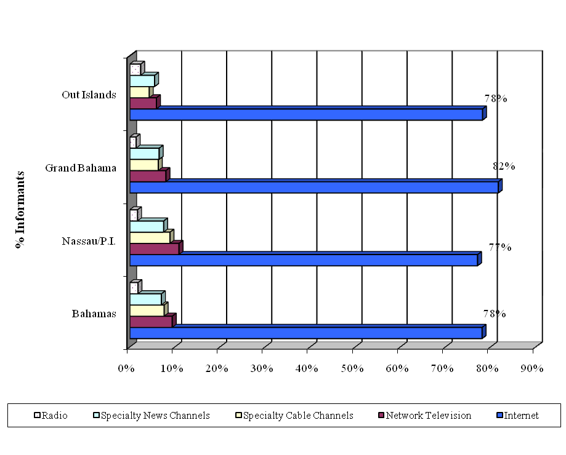

Bahamas Overall

78% of the visitors to the Islands of the Bahamas indicated that the electronic media most frequently used when planning their vacations was the Internet.
- Network Television was the next most popular electronic media used by visitors to The Islands of The Bahamas to plan their vacations.
- 9% of the visitors to the Islands of the Bahamas used Network Television when planning their vacations
- 8% used Specialty Cable Channels.
- 7% used Specialty News Channels.
- Some used a combination of methods

Nassau/Paradise Island

- 77% of the visitors to Nassau/Paradise Island used the Internet to plan their vacations.
- 11% of the visitors to Nassau/Paradise Island used Network Television when planning their vacations
- 9% used Specialty Cable Channels
- 8% used Specialty News Channels.

Grand Bahama Island

- 82% of the visitors to Grand Bahama used the Internet to plan their vacations
- 8% of the visitors to Grand Bahama used Network Television when planning their vacations
- 7% used Specialty News Channels
- 6% used Specialty Cable Channels

Out Islands

- 78% of the visitors from the Out Islands used the Internet to plan their vacations.
- 6% of the visitors to The Out Islands used Network Television when planning their vacations
- 6% used Specialty News Channels
- 4% used Specialty Cable Channels

DO YOU WATCH TELEVISION
ISLANDS OF THE BAHAMAS
2008
 | Bahamas | Nassau/P.I. | Grand Bahama | Out Islands
Yes | 85% | 87% | 87% | 75%
No | 13% | 11% | 11% | 23%
No Response | 2% | 2% | 2% | 3%
Total | 100% | 100% | 100% | 100%
DO YOU WATCH TELEVISION
ISLANDS OF THE BAHAMAS
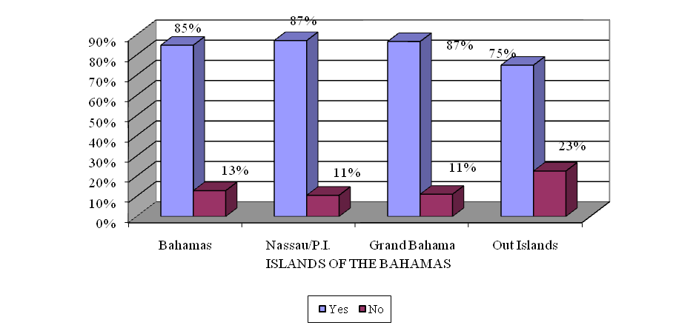

- 85% of the stopover visitors to The Islands of The Bahamas said that they watched television.
- Stopovers to the Out Islands were less likely to watch television than those to Nassau/Paradise Island and Grand Bahama. Only 75% of the stopovers to the Out Islands watched television compared to 87% of those to Nassau/Paradise Island and 87% to Grand Bahama.

- Network Television was the second most popular electronic media used by stopover visitors to The Islands of The Bahamas to plan their vacations. In addition, many visitors to the Bahamas used Network Television and other TV stations like Specialty Cable Channels, and Specialty News Channels for their viewing enjoyment.
- Although Network Television was the 2nd most popular electronic media (after the Internet) used by stopover visitors to The Islands of The Bahamas to plan their vacations they appeared to prefer Specialty News Network Stations in general when they were just watching television for their edification. CNN was the most popular television station of choice watched by stopover visitors to The Islands of The Bahamas.
- In 2007, ABC was the most popular television station viewed by visitors to the Bahamas. CNN was the 3rd most popular station. For the visitors to the Bahamas it appeared that CNN pulled ahead of the others during the electoral race for the Presidency of the United States in 2008 and the financial meltdown of September 2008.
- Visitors to the Bahamas tend to be very educated individuals so it is not surprising that they wanted to be in tune with what was going on in the United States which is the largest economy in the world based on GDP. In fact it appeared as if the world was also glued to CNN. In 2008, CNN was the 2nd most popular television station watched by visitors from both Canada and Europe and no. 1 for many other counties of the world.

Islands of The Bahamas

FAVORITE TELEVISION NETWORKS/STATIONS
ISLANDS OF THE BAHAMAS
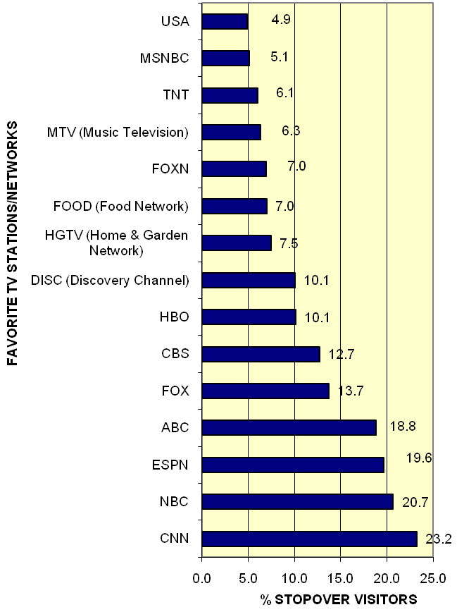

- CNN was the favorite television network/station viewed by visitors to the Bahamas. Twenty-three percent (23%) of the stopovers to the Bahamas said that CNN was one of their favorite stations.
- NBC (21%) was 2nd
- ESPN (20%) was 3rd
- ABC (19%) was 4th
- FOX (14%) was 5th CBS (13%) was 6th
Nassau/Paradise Island
FAVORITE TELEVISION NETWORKS/STATIONS
NASSAU & PARADISE ISLAND
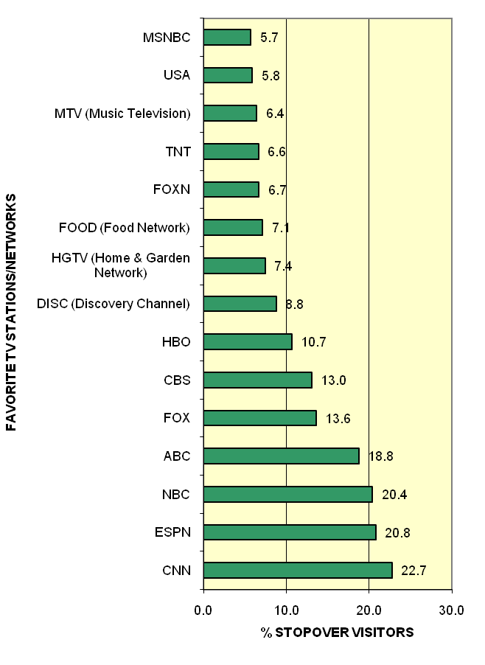
- CNN was the favorite television network/station viewed by visitors to Nassau/Paradise Island. Twenty-three percent (23%) of the stopovers to Nassau/Paradise Island said that CNN was one of their favorite stations.
- ESPN (21%) was 2nd
- NBC (20%) was 3rd
- ABC (19%) was 4th
- FOX (14%) was 5th and CBS (13%) was 6th
Grand Bahama

- CNN was the favorite television network/station viewed by visitors to Grand Bahama. Twenty-two percent (22%) of the stopovers to Grand Bahama said that CNN was one of their favorite stations.
- NBC (21%) was 2nd
- ABC (20%) was 3rd
- ESPN (15%) was 4th
- FOX (14%) was 5th
- CBS (13.7%) was 6th
Out Islands
- CNN was the favorite television network/station viewed by visitors to The Out Islands. Twenty-six (26%) of the stopovers to the Out Islands said that CNN was one of their favorite stations.
- NBC (22%) was 2nd
- ESPN (20%) was 3rd
- ABC (18%) was 4th
- FOX (14%) was 5th
- DISC (Discovery Channel 13%) was 6th
Time Visitors Most Likely to Watch Television

TIME MOST LIKELY TO WATCH TELEVISION
ISLANDS OF THE BAHAMAS
2008
 | Bahamas | Nassau/P.I. | Grand Bahama | Out Islands
6:00am to 6:59 am | 5% | 5% | 4% | 5%
7:00am to 7:59am | 12% | 13% | 12% | 12%
8:00am to 8:59am | 10% | 10% | 11% | 10%
9:00am to 9:59am | 6% | 7% | 7% | 5%
5:00pm to 5:59pm | 6% | 7% | 6% | 6%
6:00pm to 6:59pm | 18% | 18% | 18% | 18%
7:00pm to 7:59pm | 28% | 28% | 29% | 27%
8:00pm to 8:59pm | 41% | 40% | 44% | 43%
9:00pm to 9:59pm | 34% | 33% | 37% | 36%
10:00pm to 10:59pm | 27% | 27% | 27% | 27%
11:00pm to 11:59pm | 14% | 14% | 13% | 12%
Only the most popular times are shown in the above table.

- Visitors to the Bahamas Overall, Nassau/Paradise Island, Grand Bahama and the Out Islands were most likely to watch television between the hours of 6:00 p.m. in the evening to 10:59 p.m. at night.
- The most popular time however for watching television for visitors to the Islands of the Bahamas was between 8:00 p.m. to 8:59 p.m.
- 18% of the visitors to the Bahamas watched television between 6:00 p.m. to 6:59 p.m. in the evening.
- 28% of them watched television between 7:00 p.m. to 7:59 p.m.
- 41% of them watched television between 8:00 p.m. to 8:59 p.m.
- 34% of them watched television between 9:00 p.m. to 9:59 p.m.
- 27% of them watched television between 10:00 p.m. to 10:59 p.m. at night.

PRINT MEDIA CHOICES

- Over one quarter (26%) of the stopover visitors to The Bahamas used print media to plan their vacations and more than two thirds (72%) did not.
- Visitors to the Out Islands were more likely to use print media to plan their vacations than visitors to Nassau/Paradise Island and Grand Bahama. Twenty-nine percent (29%) of the stopover visitors to The Out Islands used print media to plan their vacations compared to 26% of those to Nassau/Paradise Island and 24% of those to Grand Bahama.

Twenty-six percent (26%) of the stopover visitors to the Bahamas used print media to plan their vacations. Stopovers to The Bahamas read both newspapers and magazines when they were planning their vacations. Magazines were the most popular print media used.

- Of the 26% of stopover visitors who used print media to plan their vacations, 47% of them read newspapers and 69% of them read magazines when they were planning their vacations.
- 51% of the visitors to Nassau/Paradise Island read newspapers when they were planning their vacations and 68% of them read magazines.
- 44% of the visitors to Grand Bahama Island read newspapers when they were planning their vacations and 69% of them read magazines.
- 37% of the visitors to the Out Islands read newspapers when they were planning their vacations and 75% of them read magazines.

- In 2008, 62% of the stopover visitors to the Bahamas read magazines compared to 59% in 2007 for their reading enjoyment regardless of planning a vacation, and 35% did not.
- 61% of the stopovers to Nassau/Paradise Island in 2008 read magazines for their enjoyment compared to 56% in 2007.
- 61% of them to Grand Bahama in 2008 said that they read magazines.
- 64% of the stopovers to the Out Islands read magazines for their enjoyment.

MAGAZINES THAT VISITORS WERE READING

Visitors to the Islands of the Bahamas read a very wide selection of magazines and listed over 530 magazines on the questionnaires. They read magazines that dealt with sporting activities like golf, fly fishing, boating, yachting, flying, diving, weightlifting, running, tennis, surfing, horseback riding, skiing, yoga, etc. They read magazines on motor bikes, cycling, aviation, automobile racing and automobiles. They read magazines that dealt with the latest fashions, fitness/health, muscle and fitness, beauty and makeup. They read magazines on business issues, financial matters, current events, architecture, home and garden, and home improvements. They read magazines on family, parenting, nursing, bridal matters, sewing, woodworking, cooking, gourmet cooking, food & wine, and cigars. They read magazines on nature, outdoor life, travel, computers, religion, and simply life. Visitors to the Islands of the Bahamas read such a large selection of magazines that only the top ones are listed in this report.

The top 35 magazines read by visitors to the Islands of the Bahamas, Nassau/Paradise Island, Grand Bahama and The Out Islands are shown on the following pages.

It is interesting to note that there were 3 very prominent African American magazines among the top read magazines for Grand Bahama in 2008. Ebony, Essence and Jet all appeared in the top 30 magazines read by visitors to Grand Bahama. These African American magazines were not among the top 35 magazines read by visitors to The Out Islands. Grand Bahama is known to receive a higher percentage of African American Visitors than most of the other islands in The Bahamas. Therefore it is not surprising to see more African-American magazines in the top 30 magazines.

- Stopover Visitors to the Islands of the Bahamas were primarily between the ages of 25 to 54, well educated individuals with College degrees, and with household incomes over $75,000. Most of them were also Americans. The demographics of the stopover visitors to the Bahamas were reflected in their magazine selections. The magazines enjoyed by the stopover target audience of the Bahamas were primarily very upscale.
- The magazine selections further reflect that there were some differences in interests between the stopover visitors who visit Nassau, Grand Bahama and the Out Islands.

Nassau/Paradise Island Only (In Top 35 magazines)

- In Touch/In Touch Weekly
- Shape
- Star
- Ok!Magazine

Grand Bahama Only (In Top 35 magazines)

- Bon Appetit
- Health

The Out Islands Only

The following magazines were in the top 35 magazine selections for The Out Islands but not in the top 35 for Nassau/P.I. or Grand Bahama.

- Scuba
- Islands
- Caribbean Travel
- Fly Fishing
- Forbes
- Out
- Gourmet
- Fishing (magazines)
- Business Week
- Smithsonian
One of the primary reasons stopover visitors selected the Out Islands to visit was because of the sporting attractions that were available, for example, snorkeling, fishing, scuba diving, etc. The stopover visitors to The Out Islands were primarily white, between the ages of 25-54 years of age, with more than half (51%) of the stopovers earning household incomes over $100,000. Many of the magazine selections were specialty magazines that emanated their tastes.

Nassau/Paradise Island and Grand Bahama

The following magazines were in the top 35 magazine selections for Nassau/P.I. and Grand Bah. but not in the top 35 for the Out Islands.

- Glamour
- Good Housekeeping
- Better Homes and Gardens
- Ebony
- Jet
- Essence
- Fitness
- Self
- Women’s Day

The Out Islands do not receive a large amount of African American stopover visitors compared to Nassau/Paradise Island and Grand Bahama. Most of the African American stopover visitors to the Bahamas go to Nassau/Paradise Island and Grand Bahama. A higher percentage of African Americans go to Grand Bahama than any other island in The Bahamas. Therefore magazines such as Essence, Ebony and Jet were not listed in the top 35 magazines of choice for the target audience for The Out Islands. Nine percent (8.6%) of the visitors to Grand Bahama were black, compared to 8.0% of the visitors to Nassau/Paradise Island, 3.9% of those to San Salvador, 2.1% of those to Abaco, 2.1% of those to Exuma, 1.1% of those to Bimini, 0.9% of those to Eleuthera and 0.8% of those to Andros.

Nassau/Paradise Island and The Out Islands

The following magazine was in the top 35 magazine selections for Nassau/P.I. and The Out Islands but not in the top 35 for Grand Bahama.

- GQ

Grand Bahama and The Out Islands (In Top 35 magazines)

The following magazines were in the top 35 magazine selections for Grand Bahama and The Out Islands but not in the top 35 for Nassau/P.I.

- Travel
- Travel and Leisure
- Golf Digest

The above table shows the top 25 magazines read by stopovers to the Bahamas (in percentages).

The above table shows the top 25 magazines read by stopovers to Nassau/P.I. in percentages.

The above table shows the top 25 magazines read by stopovers to Grand Bahama in percentages.

The above table shows the top 25 magazines read by stopovers to the Out Islands in percentages.

- 65% of the stopover visitors to The Bahamas said that they read newspapers but only 47% of the visitors indicated that they used newspapers when they were planning their vacations.
- 67% of the stopovers to Nassau/P.I. read newspapers but only 51% of the visitors to Nassau/P.I. indicated that they used newspapers when they were planning their vacations.
- 61% of the stopovers to Grand Bahama read newspapers but only 44% of the visitors to Grand Bahama indicated that they used newspapers when planning their vacations.
- 62% of the stopovers to the Out Islands read newspapers but only 37% of the visitors to the Out Islands indicated that they used newspapers when planning their vacations.
NEWSPAPERS THAT VISITORS WERE READING

The above graph shows the top 26 newspapers stopover visitors to the Islands of the Bahamas indicated that they read.
The above graph shows the top 26 newspapers stopover visitors to the Nassau/Paradise Island indicated that they read.

The above graph shows the top 25 newspapers stopover visitors to Grand Bahama Island indicated that they read.
The above graph shows the top 25 newspapers stopover visitors to The Out Islands indicated that they read.

The above table shows some of the Top Producing Markets for the Islands of The Bahamas and Nassau/Paradise Island. It also shows the most popular newspapers read by stopover visitors to Nassau/Paradise Island and The Bahamas from those top markets.
The above table shows some of the Top Producing Markets for Grand Bahama and the Out Islands. It also shows the most popular newspapers read by stopover visitors to those islands from some of their top markets.
NUMBER OF PEOPLE WITH E-MAIL ADDRESSES

- 84% of the stopover visitors to The Islands of the Bahamas indicated that they had an e-mail address.
- 83% of the visitors to Nassau/Paradise Island had e-mail addresses.
- 86% of the visitors to Grand Bahama had e-mail addresses
- 85% of those to the Out Islands had e-mail addresses.

NUMBER OF PEOPLE WHO SURF THE INTERNET

- 90% of the stopover visitors to the Islands of the Bahamas indicated that they “surfed” the Internet.
- 90% of the stopover visitors to Nassau/Paradise Island indicated that they "surfed" the Internet.
- 90% of the stopover visitors to Grand Bahama surfed the Internet
- 89% of the stopovers to the Out Islands "surfed" the Internet.
N.B. A key point to remember is that the Internet was the most popular electronic media used by visitors to The Islands of The Bahamas to plan their vacations. This was the case for visitors to Nassau/Paradise Island, Grand Bahama and the Out Islands.
FAVOURITE INTERNET SEARCH ENGINES &/OR CONTENT PROVIDERS

The top 4 Internet Search Engines/content providers for the Islands of the Bahamas were:
- Google (82%)
- Yahoo (41%)
- AOL (18%) –A higher % of Americans use AOL than Canadians
- MSN (15%)

LIKELIHOOD TO RETURN TO BAHAMAS
- 87% of the stopovers were likely to return to the Bahamas in 1-5 yrs (i.e., 59.5% were very likely and 27.1% were somewhat likely to return). 7.8% said somewhat unlikely, 4.8% said that they were not at all likely to return.
- 86% of the stopovers to Nassau/P.I. said that they were likely to return (i.e., 57.6% were very likely and 28.5% were somewhat likely to return). 8.1% said that they were somewhat unlikely, and 5.1% said that they were not at all likely to return.
- 82% of the stopovers to Grand Bahama said that they were likely to return (i.e., 53.8% were very likely and 28.6% were somewhat likely). 9.6% said somewhat unlikely and 7.0% said that they were not at all likely to return.
- 92% of the stopovers to the Out Islands said that they were likely to return (i.e., 71.6% were very likely and 20.6% were somewhat likely to return). 5.2% said that they were somewhat unlikely, and 1.9% said that they were not at all likely to return.

LIKELIHOOD OF RECOMMENDING THE BAHAMAS

- 93% of the stopovers were likely to recommend the Bahamas to friends and relatives (i.e., 69.6% were very likely and 22.9% were somewhat likely to recommend). 4.2% were somewhat unlikely and 2.4% were not at all likely to recommend the Bahamas.
- 92% of the stopovers to Nassau/P.I. said that they were likely to recommend (i.e., 68.5% were very likely and 23.8% were somewhat likely to recommend). 4.4% said that they were somewhat unlikely, and 2.5% were not at all likely to recommend the Bahamas.
- 89% of the stopovers to Grand Bahama said that they were likely to recommend (i.e., 62.9% were very likely and 25.9% were somewhat likely to recommend). 6.0% said that they were somewhat unlikely, and 3.8% were not at all likely to recommend the Bahamas.
- 97% of the stopovers to the Out Islands were likely to recommend (i.e., 79.9% were very likely and 16.7% were somewhat likely to recommend). 1.9% of the stopovers said that they were somewhat unlikely, and 0.9% of them were not at all likely to recommend the Bahamas.

VISITORS WHO WERE NOT LIKELY TO RETURN TO THE BAHAMAS

The stopover visitors who were not likely to return indicated the following reasons:

Bahamas Overall

There was an improvement in the percentage of visitors who said that they were not likely to return to the Bahamas between 2008 and 2007. In 2008, 13% of the stopovers to the Bahamas Overall indicated that they were unlikely to return to the Bahamas in 1-5 years compared to 18% in 2007. The visitors who said that they would not return gave the following reasons:
- High prices
- They wanted to go somewhere else
- They were dissatisfied with their hotel (i.e., service, quality & prices)
- Poor Service
- Poor attitudes of the people
- Food (i.e. poor quality, high prices)
- Litter
- Crime (Visitors are concerned about the increase in crime, e.g. stuff stolen from their rooms, or the beach, or other robberies).

Nassau/Paradise Island

There was an improvement in the percentage of visitors who said that they were not likely to return to the Nassau/P.I. between 2008 and 2007. In 2008, 13% of the stopover visitors to Nassau/Paradise Island said that they would not return compared to20% in 2007. The visitors who said that they would not return gave the following reasons:

- High Prices
- They wanted to go somewhere else
- Didn’t like the hotel where they stayed because of one or more of the following: poor facilities, poor service, hotel too expensive, poor food in hotel, unfriendly people in hotel
- Poor service
- The poor attitudes of the people
- Food (i.e. poor quality, high prices)
- Litter
- Crime

Grand Bahama Island

There was an improvement in the percentage of visitors who said that they were not likely to return to Grand Bahama between 2008 and 2007. In 2008, 17% of the stopover visitors to Grand Bahama Island indicated that they were unlikely to return to the Bahamas in 1-5 years compared to 21% in 2007. The visitors who said that they would not return gave the following reasons:

- They wanted to go somewhere else
- Hotel dissatisfaction
- The poor attitudes of the people
- Poor service
- High Prices
- Lack of Activities
- Food (poor quality, too expensive)
- Beaches (Litter on them, etc.)

Out Islands

The Out Islands always enjoyed the highest visitor return and recommend rate of The Islands of the Bahamas but there was still an even a greater improvement in the percentage of visitors who said that they were not likely to return to The Out Islands between 2008 and 2007. In 2008, 7% of the stopover visitors to The Out Islands indicated that they were unlikely to return to the Bahamas in 1-5 years compared to 9% in 2007. The visitors who said that they would not return gave the following reasons:

- They wanted to go somewhere else
- The poor attitudes of the people
- Hotel dissatisfaction
- Poor service
- Environment (need to protect it, etc.)
- Bad weather (too hot, too cold, etc.)
- High Prices
- Litter

VISITORS NOT LIKELY TO RECOMMEND THE BAHAMAS

Bahamas Overall

There was an improvement in the percentage of visitors who said that they were not likely to recommend the Bahamas between 2008 and 2007. In 2008, 7% of the stopovers said that they were not likely to recommend the Bahamas to friends and relatives compared to 10% in 2007. Visitors who were not likely to recommend the Bahamas to their friends and relatives gave some of the following reasons:

- High Prices
- Hotel dissatisfaction (Didn’t like the hotel where they stayed)
- Poor service
- The poor attitudes of the people
- Lack of activities
- Litter
- Restaurants (poor service, too expensive, not enough of them)
- Poor Value for money
- Food (poor quality, too expensive)

Nassau/Paradise Island

There was an improvement in the percentage of visitors who said that they were not likely to recommend the Bahamas between 2008 and 2007. In 2008, 7% of the stopovers to the Nassau/Paradise Island said that they would not recommend the Bahamas to their friends and relatives compared to 11% in 2007. Visitors who were not likely to recommend the Bahamas to their friends and relatives gave some of the following reasons:

- High Prices
- The poor attitudes of the people
- Didn’t like the hotel where they stayed because of one or more of the following: poor facilities, poor service, hotel too expensive, unfriendly people in hotel
- Poor service
- Poor Value for money
- Litter

Grand Bahama Island

There was an improvement in the percentage of visitors who said that they were not likely to recommend the Bahamas between 2008 and 2007. In 2008, 10% of the stopover visitors to Grand Bahama Island indicated that they were unlikely to recommend the Bahamas to friends and relatives compared to 13% for 2007. Visitors who were not likely to recommend the Bahamas to their friends and relatives gave the following reasons:

- The poor attitude of the people
- High Prices
- Hotel dissatisfaction (Didn’t like the hotel where they stayed)
- Poor service
- Food (poor quality, too expensive)
- Litter
- Lack of Activities

Out Islands

There was an improvement in the percentage of visitors who said that they were not likely to recommend the Bahamas between 2008 and 2007. In 2008, 3% of the stopover visitors to the Out Islands indicated that they were unlikely to recommend the Bahamas to friends and relatives compared to 5% for 2007. Visitors who were not likely to recommend the Bahamas to their friends and relatives gave some of the following reasons:

- Litter
- High Prices
- Airlines
- Environmental issues (bugs, destruction of mangroves, etc.)

Top Compliments
- General (38% of the comments received, e.g. “loved it”)
- The people (30% of the comments received)
- Scenery (6% of the comments received)
- Beaches (4% of the comments received)
- Hotel (3% of the comments received)
- Relaxation (3% of the comments received)

Top Complaints
- High prices (15% of the comments received)
- Poor attitudes of the people (10% of the comments received)
- Hotel not as expected (9% of the comments received. e.g. too expensive, rude hotel staff, poor facilities, poor service)
- Litter (8% of the comments received)
- Food (7% of the comments received. e.g. high prices and poor quality)
- Airport (7% of the comments received. e.g. not up to standards, need fixing up/upgrade, overcharging at airport, rude people at airport, food at airport not good, more food options at airport, better signage, A/C not working properly)

Top Compliments
- General (39% of the comments received, e.g. “loved it, very nice”)
- The people (30% of the comments received)
- Scenery (5% of the comments received)
- Hotel (3% of the comments received)
- Beaches (3% of the comments received)
- Food (2% of the comments received)

Top Complaints
- High prices(17% of the comments received)
- Poor attitudes of the people(11% of the comments received)
- Hotel not as expected (9% of the comments received, i.e., too expensive, poor facilities, poor service, rude hotel staff)
- Airport not up to standards (8% of the comments received. e.g. not up to standards, need fixing up/upgrade, overcharging at airport, rude people at airport, food at airport not good, more food options at airport, better signage, A/C not working properly)
- Food (8% of the comments received. e.g. high prices and poor quality)
- Too much litter(7% of the comments received)
- Poor Service(6% of the comments received)

Top Compliments
- General (34% of the comments received, e.g. “enjoyed the visit”)
- The people (32% of the comments received)
- Beaches (6% of the comments received)
- Scenery (5% of the comments received)
- Relaxation (3% of the comments received)
- Climate/Weather (3% of the comments received)

Top Complaints
- High prices (11% of the comments received)
- Poor attitude of the people (11% of the comments received)
- Hotel dissatisfaction (10% of the comments received e.g. too expensive, poor facilities, poor service, rude hotel staff)
- Poor Service (8% of the comments received)
- Food (7% of the comments received. e.g. high prices and poor quality)
- Litter (6% of the comments received)

Top Compliments
- General (41% of the comments received. e.g. “It was wonderful”)
- The People (27% of the comments received)
- Scenery (9% of the comments received)
- Beaches (4% of the comments received)
- Relaxation (3% of the comments received)
- Sea/Water (3% of the comments received)

Top Complaints
- Litter (19% of the comments received)
- Roads/Traffic (8% of the comments received)
- High prices (8% of the comments received)
- Environment (8% of the comments received. e.g. “hate the sand flies”, destruction of the eco-system)
- Airlines (8% of the comments received)
- Development (6% of the comments received)

RESERVATION BOOKINGS

- The use of travel agents has been declining steadily over the years as visitors began to use other ways (e.g. Internet) of booking their reservations.
- In 1997, 72% of the stopover visitors used a travel agent to book their reservations compared to only 30% in 2008. Thirty-three percent (33%) of stopovers to Nassau/Paradise Island in 2008 indicated that they had used a travel agent to book their reservations compared to 54% in 2003, 61% in 2002, 68% of them in 2001 and 76% in 1997.
- Twenty-four percent (24%) of the stopovers in 2008 to Grand Bahama had used a travel agent compared to 52% in 2002, 60% in 2001 and 72% in 1997.
- Twenty-four percent (24%) of the stopover visitors in 2008 to the Out Islands had used a travel agent compared to 34% in 2002 and 40% in 2001.
- In 2007, a higher percentage of Canadians used tour operators and travel agents than their American and European counterparts. By 2008 however, they appeared to greatly relinquish their stronghold on tour operator/travel agents.
  - In 2008, 33% of the stopover visitors from Canada used a tour operator/travel agent to book their travel experience compared to 52% in 2007. They began to do as many Americans had been doing for years they began to use the online services more.
  - There was a significant increase in the percentage of Canadians booking online in 2008 compared to 2007. In 2008, 57% of Canadians used online services to book a part of or all of their reservations compared to 49% of them in 2007, an increase of 8 percentage points. One possible reason for this change was the global recession which began in December 2007 and really began to show itself in September 2008 with the financial meltdown that occurred in that month. After this meltdown more and more persons began to look for bargains and hence, the Internet for Canadians became a very viable option.

AMOUNT OF TIME BETWEEN RESERVATION & VISITOR’S ARRIVAL

In 2008, stopover visitors to The Islands of The Bahamas booked their reservations anywhere from 7 months in advance to the very same month of travel. Short lead times seemed to be preferred as the highest percentage of visitors booked 1-3 months in advance or the very same month of travel. There was a very small amount of stopover visitors who booked their reservations 7 months to a year in advance of traveling to the Bahamas.
TOUR OPERATORS AND TRAVEL AGENTS

30% of the visitors to the Islands of the Bahamas used a tour operator or travel agent. 54% said that they used an online Internet service to book their reservations.

A higher percentage of stopovers to Nassau/P.I. (33%) used a Tour Operator/ Travel Agent than those to Grand Bahama (24%) and the Out Islands (24%).

Some visitors to the Bahamas used tour operators and travel agents to book their reservations.

Some booked their reservations directly with the hotel or airline via phone, etc. Some booked their reservations directly on the Internet and others used a combination of methods.

- Of the 30% of the stopover visitors that used the tour operator/travel agent to book their reservations in 2008:
  - 74% of them booked their airline with the TO/TA
  - 71% of them booked their hotel with the TO/TA
  - 39% of them booked their transfers from the airport with the TO/TA
  - 12% of them booked their on-island activities with the TO/TA
  - 5% of them booked their rental car with the TO/TA
- A higher percentage of stopover visitors to Grand Bahama used online services to book their reservations than those to Nassau/P.I. and the Out Islands. Visitors to The Out Islands used online services less than those to Nassau/P.I. and Grand Bahama.
- 54% of the stopovers said that they had used an online service to book some or all of their reservations to the Bahamas.
- 54% of them to Nassau/Paradise Island used an online service to book their reservations.
- 64% of them to Grand Bahama used an online
- 47% of the stopovers to the Out Islands used an online service to book their reservations. Some of them booked their reservations directly with the hotels, etc.

- Of the 54% of the stopover visitors that used the Internet to book their reservations in 2008:
  - 86% of them booked their airline online
  - 51% of them booked their hotel online
  - 12% of them booked their transfers from the airport online
  - 6% of them booked their on-island activities online
  - 4% of them booked their rental car online

- It is clear that many stopover visitors are using a combination of methods to book their reservations to the Bahamas. Some of them are booking their airline online and then booking their hotel directly by phone or with a tour operator/travel agent.
- A higher percentage of stopovers used a tour operator/travel agent (39%) to book their airport transfers than those who used an online service (12%). It is clear that many stopovers are still waiting until they arrive in the destination to book their airport transfers, for example with the taxi drivers at the airport directly.
- A higher percentage of stopovers used a tour operator/travel agent (12%) to book their on-island activities than those who used an online service (6%).
- Rental cars that were booked by visitors were primarily booked directly with the rental car company either before or after the visitor arrived in The Bahamas. Tour Operators/Travel Agents and Online services were not used heavily to book this service.

- Some stopover visitors to the Bahamas stay on more than one island in the Bahamas and use one tour operator/travel agency to book their reservations in all of these islands.
- In the following pages with the tour operators/travel agencies you will see that this happened with some of the islands.

MOST POPULAR ONLINE BOOKING SERVICES USED
STOPOVERS TO NASSAU/PARADISE ISLAND
2008
Expedia.com | Nwa.com | Sheraton.com
Atlantis.com | Virgin-atlantic.com | Skyauction.com
Orbitz.com | Yahoo.com | Starwood/westin.com
Travelocity.com | Americanexpress.com | Superclubs.com
Jetblue.com | Bookit.com | Travelzoo.com
AA.com | Comfortsuites.com | Usairwaystravel.com
Sandals.com | Continental.com | Vacationstogo.com
Usairwaysvacations.com | Coralsands.com | Westjet.com
Carlsonwagonlit.com | Cosco.com | Wyndham.com
Delta.com/deltavacations.com | Fourseasons.com
Spiritair.com | Funjet.com
Bahamasair.com | Hotels.com
Continental.com | Hotwire.com
Cheaptickets.com | Intervalinternational.com
Aircanada.com | Itravel2000.com
Bahamas.com | Kayak.com
Ba.com | Priceline.com
Firstchoice.co.uk | RCI.com
Gradcity.com | RIU.com
This list is not all-inclusive of every online service used.
(Source: Immigration Cards and Tour Media Exit Survey, 2008)

Conclusion

Stopover visitors came to the Islands of the Bahamas primarily for the purpose of vacationing. Their decision to visit The Bahamas was primarily influenced by the beaches, the climate, the need for rest and relaxation, the hotel facilities (this was especially true for Nassau/Paradise Island), the friendly people they expected to meet in the destination, the ease of getting to the destination, the fact that they had never been here before, the perceived safety of the islands, the exotic nature of the islands and the casinos. Visitors to Grand Bahama also mentioned the perceived best value for money that they expected to receive as a major influence for deciding to visit the destination. In addition to the other major influences already mentioned, visitors to the Out Islands were also influenced to visit the islands because of the sporting attractions offered in these islands (e.g. fishing, boating, diving, snorkeling, etc.), and the fact that they had friends there.

Stopover visitors to the Bahamas wanted to participate in a number of different activities when they came to the islands. Most of them wanted to enjoy the beaches. Many of them want to simply “kick back” and relax. Some of them wanted to do some shopping (e.g. Nassau/P.I. & Grand Bahama), go snorkeling, go to the casinos (e.g. Nassau/P.I. & Grand Bahama), or take an island tour. Some of them wanted to go diving (e.g. Andros, Bimini), go sailing (e.g. Abaco), go deep sea fishing (Bimini), go golfing (Exuma), and go bone-fishing (e.g. Andros). Some of them even wanted to go bird-watching.

Stopovers came for vacation and to enjoy various activities. The electronic media most frequently used by these visitors to the Islands of the Bahamas when they planned a vacation was the Internet (Some of the top Internet search engines and content providers for visitors to the Bahamas were: Google, Yahoo, AOL, and MSN). The second most popular electronic media was Network Television. The third most popular electronic media was Specialty Cable Channels and the fourth most popular was Specialty News Channels.

In addition to the Internet, stopover visitors used the television when planning their vacations. Most stopover visitors said that they watched television although they did not all use TV specifically to plan their vacations. The favorite television networks/stations of visitors to the Islands of the Bahamas were: CNN (Specialty News Station), NBC (Network Station), ESPN (Specialty Cable Channel), ABC (Network Station), FOX (Network Station), CBS (Network Station), HBO (Specialty Cable Channel), Discovery Channel (Specialty Cable Channel), HGTV/Home and Garden Network (Specialty Cable Channel), the FOOD Network (Specialty Cable Channel), FOXN (Specialty News Station), MTV (Music Television), TNT and MSNBC (Specialty News Station).

Visitors to the Islands of the Bahamas primarily watched television between 6:00 p.m. and 10:59 p.m. at night. The most popular time of day for watching television was between 8:00 p.m. to 8:59 p.m.

In addition to watching television, some visitors to the Bahamas also read newspapers and magazines for their own personal enjoyment and some of them also read them when planning their vacations. Magazines were the most popular print media used by visitors to the Bahamas when planning their vacations. More than half of the stopover visitors to the Bahamas read magazines for their reading enjoyment. Visitors read a very wide selection of magazines. Some of the top magazines for visitors to the Islands of the Bahamas as a whole were: People, Time Magazine, Cosmopolitan/Cosmo, US/US Weekly, Newsweek, Sports Illustrated, Glamour, O (Oprah), Vogue/Vogue Living, National Geographic Explorer, Men’s Health, In Style, Vanity Fair, Economist, Good Housekeeping, Better Homes and Gardens, the New Yorker, GQ, Fitness, Essence, Readers Digest, Ebony, Conde Nast Travel, Elle Décor, and Travel and Leisure.

Almost two thirds of the stopover visitors read newspapers regardless of planning a vacation but only one half read them when actually planning their vacations. Some of the top newspapers read by visitors to The Bahamas were: USA Today, The New York Times, Wall Street Journal, Washington Post, New York Post, Newsday, Globe and Mail, Boston Globe, Miami Herald, the Daily News, Sun Sentinel, Atlanta Journal-Constitution, Los Angeles Times, Toronto Star, the Chicago Tribune, Philadelphia Inquirer, Houston Chronicle and the New York Daily News.

Stopover visitors used the Internet, television, magazines and newspapers for their enjoyment as well as to plan their vacation experiences. When it came time to take the next step, some stopover visitors booked their reservations directly on the Internet (54%), some used tour operators and travel agents (30%) and some booked their reservations directly with the hotel or airline, etc. Others used a combination of methods. Stopover visitors to the Bahamas were more likely to book their airport transfers with a Tour Operator/Travel Agent than online however, many of them still preferred to wait until they arrived in the destination and use the available transportation at the airports (e.g. taxis). In addition, stopover visitors to the Bahamas were more likely to book their on-island activities with a Tour Operator/Travel Agent than online however, many of them still preferred to wait until they arrived in the destination before they booked their on-island activities. Visitors who booked rental cars tended to do so directly with the rental car company either before or after their arrival in the Bahamas.

Some of the visitors to the Islands of the Bahamas who booked their reservations online used: expedia.com, atlantis.com, orbitz.com, travelocity.com, aa.com, jetblue.com, Usairwaysvacations.com, continental.com, sandals.com, spiritair.com, carlsonwagonlit.com, delta.com/deltavacations.com, cheaptickets.com, bahamasair.com, Bahamas.com, aircanada.com, ba.com, firstchoice.co.uk, gradcity.com, nwa.com, (these online services that follow are listed in alphabetical order) airfrance.com, americanexpress.com, aol.com, Bahamasvacations.com, bookit.com, Clubmed.com/clubmed.ca, Colpittsworldtravel.com, Comfortsuites.com, Cosco.com, Fourseasons.com, Funjet.com, Grandbahamavacations.com, hotels.com, hotwire.com, Intervalinternational.com, Kayak.com, Macystravel.com, Paradiseislandvacations.com, priceline.com, RCI.com, RIU.com, Sheraton.com, Skyauction.com, Smallhope.com, Spg.com, Starwood.com/Westin.com, Superclubs.com, Travelzoo.com, United .com, Usairwaystravel.com,Vacationstogo.com, Virtuallythere.com, Westjet.com, Wyndham.com, and Yahoo.com, etc.

Some of the most popular tour operators/travel agents used by the stopover visitors to the Bahamas Overall were: Liberty Travel, American Express Travel, Discovery Cruise Line, AAA Travel/Triple AAA, Club Med, RCI Travel, Security Travel, GOGO Worldwide Vacations/GOGO Tours, Apple Vacations, Student City, Thomas Cook Travel, Uniglobe Travel, Travel Impressions, Maritz Travel, and Bel Air Travel.

Moreover, visitors to the Bahamas seemed to prefer short lead times when booking their reservations. The highest percentage of visitors booked their reservations 1-3 months in advance or the very same month of travel.

More than half of the visitors to the Islands of the Bahamas were repeat visitors. Eighty-seven percent (87%) of the stopovers said that they would return to the Bahamas in 1-5 years. Ninety-three percent (93%) said that they would recommend the Bahamas to their friends or relatives.

Visitors to The Islands of The Bahamas who were not likely to return or recommend the Bahamas to friends and relatives gave the following reasons: high prices (too expensive), they wanted to visit other places, hotel dissatisfaction (e.g., poor accommodations, rude staff, poor hotel service), poor service, poor attitudes of the people, food (too expensive or poor quality), litter/cleanliness (country was too dirty), and crime.

Stopover visitors to the Bahamas were primarily white, between the ages of 25-54, college educated, with annual household incomes over $75,000. In fact, almost half of them (49%) had household incomes of $100,000 or more.

APPENDIX

TOUR OPERATOR AND MEDIA EXIT SURVEY

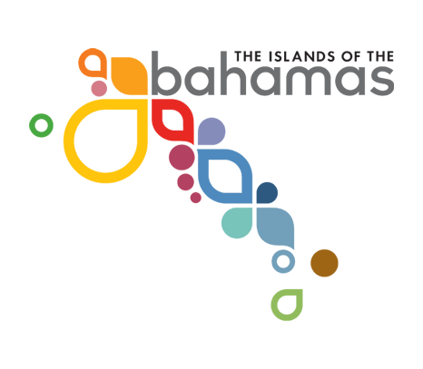
Dear Visitor,

The Government of the Bahamas would like to thank you for choosing the Islands of the Bahamas for this visit.

Tourism is our number one Industry and we would like to invite you to share your opinions and your media habits with us so that we would be able to serve you better.

We would be grateful if you would help us by filling out this questionnaire. It should only take a few moments of your time. All information will be treated confidentially.

Thank you for taking the time to help us. We greatly appreciate it.

- WHAT WAS THE MAIN REASON FOR THIS VISIT TO THE BAHAMAS? (PLEASE “X” ONE BOX ONLY)
Business Trip………………………………………… [ ]1
Convention/Conference……………………………… [ ]2
To Get Married………………………………………. [ ]3
To Attend Wedding………………………………… [ ]4
Honeymoon……………………………………….…. [ ]5
Vacation……………………………………………... [ ]6
Visiting friends or relatives…………………………. [ ]7
Casino excursion…………………………………….. [ ]8

Other (PLEASE WRITE IN)________________________

2. WHAT INFLUENCED YOUR DECISION TO VISIT THE BAHAMAS? (PLEASE “X” AS MANY BOXES AS APPLY)
Beaches………... [ ]1 Best value for money…… [ ]12
Climate.………. [ ]2 Good package deals…… [ ]13
Safety of islands. [ ]3 Rest & Relaxation……… [ ]14
Hotel Facilities… [ ]4 Heard a lot about the Bah. [ ]15
Casinos………… [ ]5 Friend recommended Bah [ ]16
Nightlife……… [ ]6 Had friends in the Bah.…. [ ]17
Sports (eg.diving)[ ]7 Never been here before…. [ ]18
Exotic Islands…. [ ]8 Travel Agent/Tour Operat. [ ]19
Shopping………. [ ]9 Bahamas website……….. [ ]20
Friendly people... [ ]10 Saw Ad on TV………….. [ ]21
Easy to get to….. [ ]11 Saw Ad in Magazine……. [ ]22

Other___________________________________________

3. WHAT ACTIVITIES DID YOU INTEND TO DO ON THIS VISIT TO THE BAHAMAS? (PLEASE “X” AS MANY BOXES AS APPLY)
Enjoy Beaches… [ ]1 Go on an Island Tour ….. [ ]7
Shop…………… [ ]2 Go Golfing……………… [ ]8
Go Birdwatching [ ]3 Go Snorkeling….............. [ ]9
Rest & Relax …. [ ]4 Go Diving………………. [ ]10
Go to Casinos….. [ ]5 Go Bonefishing…………. [ ]11
Go Sailing……... [ ]6 Go Deep Sea Fishing…… [ ]12

Other___________________________________________

4. WHEN DID YOU MAKE YOUR RESERVATIONS?
(PLEASE WRITE IN)

Month_____________ Year_______________

5. DID YOU USE AN ONLINE SERVICE (INTERNET) TO BOOK ANY OF YOUR RESERVATIONS?

1. Yes [ ] 2. No [ ] Go to question 7

6. WHICH ONLINE BOOKING SERVICE DID YOU USE TO MAKE YOUR RESERVATIONS TO THE BAH.?

Expedia.com…... [ ]1 Hotwire.com…... [ ]5
Travelocity.com. [ ]2 Yahoo.com…….. [ ]6
Orbitz.com…….. [ ]3 Hotels.com…….. [ ]7
Priceline.com...... [ ]4 Cheaptickets.com [ ]8

Other Internet Service (Please Write In)________________

What Items Did You Book Online? (Please “X” As Many As Apply)

Used the Internet to book:
Airline……………………………………… [ ]1
Hotel……………………………………….. [ ]2
Rental Car…………………………………. [ ]3
Transfers from Airport…………………….. [ ]4
On-island activities (e.g. tours).…………… [ ]5

7. DID YOU USE A TOUR OPERATOR/TRAVEL AGENT TO BOOK ANY OF YOUR RESERVATIONS?

1. Yes [ ] 2. No [ ] Go to question 8

(Please Write in Name of Tour Operator/Travel Agent)

Tour Operator &/or Travel Agent Used__________________

Town/City where booked_____________________________

WHAT ITEMS DID YOU PURCHASE FROM THE TOUR OPERATOR/TRAVEL AGENT? (Please “X” As Many As Apply)

Used a travel agent/tour operator to book:
Airline……………………………………… [ ]1
Hotel……………………………………….. [ ]2
Rental Car…………………………………. [ ]3
Transfers from Airport…………………….. [ ]4
On-island activities (e.g. tours).…………… [ ]5

8. DID YOU BOOK ANY OF YOUR RESERVATIONS DIRECTLY WITH AIRLINE, HOTEL OR OTHER COMPANIES?

1. Yes [ ] 2. No [ ] Go to question 9

Booked reservations directly with:
Airline……………………………………… [ ]1
Hotel……………………………………….. [ ]2
Rental Car…………………………………. [ ]3
Transport companies (e.g. taxis)…………… [ ]4
On-island activities (e.g. tours.…………… [ ]5

9. WHEN PLANNING YOUR VACATION, WHAT IS THE ELECTRONIC MEDIA MOST FREQUENTLY USED? (PLEASE “X AS MANY BOXES AS APPLY)

Specialty Cable Channels (e.g. Lifetime)…………… [ ]1
Specialty News Channels (e.g. CNN, MSNBC)…….. [ ]2
Network Television, e.g. ABC, NBC,CBS………….. [ ]3
Radio………………………………………………… [ ]4
Internet………………………………………………. [ ]5

Other (PLEASE WRITE IN)__________________________

10. DO YOU WATCH TELEVISION?

1. Yes [ ] 2. No [ ] Go to question 12

WHAT ARE YOUR FAVORITE TELEVISION STATIONS (CABLE OR SATELLITE)?

______________________ _____________________

______________________ _____________________

11. AT WHAT TIME ARE YOU MOST LIKELY TO WATCH TELEVISION? (PLEASE WRITE IN)

_____________________a.m. _________________p.m.

12. DO YOU USE PRINT MEDIA SUCH AS NEWSPAPERS AND MAGAZINES TO PLAN YOUR VACATION?

1. Yes [ ] 2. No [ ] Go to question 13

When Planning Your Vacation, What Is The Print Media Most Frequently Used? (Please “X As Many Boxes As Apply)

Newspaper…………………………………………… [ ]1
Magazine……………………………………………. [ ]2

Other (PLEASE WRITE IN)__________________________

13. DO YOU READ ANY NEWSPAPERS?

1. Yes [ ] 2. No [ ] Go to question 14

What Newspapers Do You Read? (Please Write In)

______________________ _____________________

______________________ _____________________

14. DO YOU READ ANY MAGAZINES?

1. Yes [ ] 2. No [ ] Go to question 15

What Magazines Do You Read? (Please Write In)

______________________ _____________________

______________________ _____________________

15. DO YOU HAVE AN E-MAIL ADDRESS? (PLEASE “X” ONE BOX ONLY)
Yes………[ ]1 No………[ ]2

16. DO YOU SURF THE INTERNET?(PLEASE “X” ONE BOX ONLY)
Yes………[ ]1 No………[ ]2 If no, go to question 18

17. WHAT INTERNET SEARCH ENGINE (S) &/OR CONTENT PROVIDER ( S) DO YOU USE?
(PLEASE “X” AS MANY BOXES AS APPLY)

AOL….. [ ]1 Lycos… ……….. [ ]5 Dogpile. [ ]14
Yahoo... [ ]2 Alta Vista……… [ ]6 Earthlink.. [ ]15
Excite… [ ]3 Hotbot………… [ ]7 MSN…. [ ]24
Google [ ]4 Infoseek………. [ ]8
Other______________________________

18. HAVE YOU EVER VISITED THE BAHAMAS BEFORE BY AIR, BY PRIVATE BOAT, OR A CRUISE SHIP?

Yes……….[ ]1 No……….[ ]2 If no, go to quest. 20

19. NOT COUNTING THIS TRIP, HOW MANY TIMES HAVE YOU EVER VISITED THE BAHAMAS?

One….. [ ]1 Three…. …..[ ]3 Ten to Nineteen... [ ]5
Two…... [ ]2 Four to Nine[ ]4 Twenty or more.. [ ]6

20. HOW LIKELY ARE YOU TO RETURN TO THE BAHAMAS FOR A VACATION IN THE NEXT 1-5 YRS? (PLEASE “X” ONE BOX ONLY)

Very Likely……. [ ]1 Somewhat UnLikely……. [ ]3
Somewhat Likely [ ]2 Not at all Likely………… [ ]4

If not at all likely to return, Why not?__________________

_________________________________________________

_________________________________________________

21. HOW LIKELY ARE YOU TO RECOMMEND THE BAHAMAS TO YOUR FRIENDS OR RELATIVES? (PLEASE “X” ONE BOX ONLY)

Very Likely……. [ ]1 Somewhat UnLikely…… [ ]3
Somewhat Likely [ ]2 Not at all Likely………… [ ]4

IF not at all likely to recommend, Why not?_____________

__________________________________________________

__________________________________________________

22. IF YOU STAYED AT A HOTEL (S), GUEST HOUSE OR RENTED COTTAGE, PLEASE WRITE IN THE
NAME (S).

________________________________________________

Did not stay in hotel, guest house or cottage………[ ]

FOR STATISTICAL PURPOSES ONLY.

23. INCLUDING YOURSELF, WRITE IN THE NUMBER OF PEOPLE TRAVELLING WITH YOU?

___________________PEOPLE

24. WHERE DO YOU LIVE?

United States [ ]1 State:________ Zip Code:__________

Canada …… [ ]2 Province:_____ PostalCode:_________

Other (PLEASE WRITE IN COUNTRY):__________
Zip/Postal Code______________

25. WHAT IS YOUR AGE? (PLEASE “X” ONE BOX ONLY)

12 to 17…………[ ]1 45 to 54 years…………… [ ]5
18 to 24………... [ ]2 55 to 64 years…………… [ ]6
25 to 34………... [ ]3 65 years or over………… [ ]7
35 to 44………... [ ]4

26. ARE YOU…..(PLEASE “X” ONE BOX ONLY)

Male………... [ ]1 Female……… [ ]2

27. WHAT IS THE HIGHEST LEVEL OF EDUCATION THAT YOU HAVE COMPLETED? (PLEASE “X” ONE BOX ONLY)

High school or less……[ ]1 College graduate.[ ]3
Some college………….[ ]2 Post graduate….. [ ]4

28. INCLUDING YOURSELF AND ANY INFANTS, HOW MANY PEOPLE ARE THERE CURRENTLY LIVING IN YOUR HOUSEHOLD? (PLEASE “X” ONE BOX ONLY)

One……………………… [ ]1
Two…………………….. [ ]2
Three to Four…………… [ ]3
Five or more…………… [ ]4

29. WHAT IS YOUR TOTAL HOUSEHOLD INCOME BEFORE TAXES IN U.S. DOLLARS? (PLEASE “X” ONE BOX ONLY)

Under $25,000……….[ ]1 $150,001 to $200,000[ ]7
$25,001 to $50,000… [ ]2 $200,001 to $250,000[ ]8
$50,001 to $75,000… [ ]3 $250,001 to $325,000[ ]9
$75,001 to $100,000...[ ]4 $325,001 to $400,000[ ]10
$100,001 to $125,000.[ ]5 $400,001 to $500,000[ ]11
$125,001 to $150,000.[ ]6 Over $500,000……....[ ]12

30. WHICH OF THE FOLLOWING BEST DESCRIBES YOUR ETHNIC ORIGIN? (PLEASE “X” ONE BOX ONLY)

[ ]1 White
[ ]2 Black
[ ]3 Hispanic
[ ]4 Mixed Race/Mixed Heritage
[ ]5 Asian/Pacific Islander
[ ]6 American Indian/Alaska Native

Other (Please Write In)_______________________________

31. WHAT OTHER COMMENTS, IF ANY, WOULD YOU LIKE TO MAKE ABOUT YOUR VISIT TO THE BAHAMAS? (PLEASE WRITE IN)
__________________________________________________

__________________________________________________

__________________________________________________

FOR OFFICE USE ONLY

Place of Survey……….. [ ] Year………. [ ]
Enumerator……………. [ ] Col………….. [ ]
Month…………………. [ ] Coder……….. [ ]

